Announcements
Faith Enrichment Opportunities

Children’s Church Sundays @ 10:20 am

Faith Enrichment Classes Sundays @ 11:30 am
Children, Youth, and Adult Classes

Bible Study with Pastor and Lady Bates
Wednesdays @ 7 pm on Facebook Live

May
Graduate Recognition and Celebration
Sunday, May 19th @ 10 am

Family and Friends Day
Sunday, May 26th @ 10 am
Food / Fellowship / Games after Worship Service

July
Vacation Bible School
Save the Dates – June 8-11, 2024

April Birthdays
David Bamundaga 4/10
Rya Barnes 4/15
Eldridge Pollard 4/15
Kaydence Walton 4/15
Alfie Wines 4/17
Zaniah Brown 4/24
Leon Rischer 4/26
Fatima Parsons 4/29

Ways to Give

Cash App - $Givetograce
Paypal – Gracemetroplex.org
Zelle – See Your Banking Institution
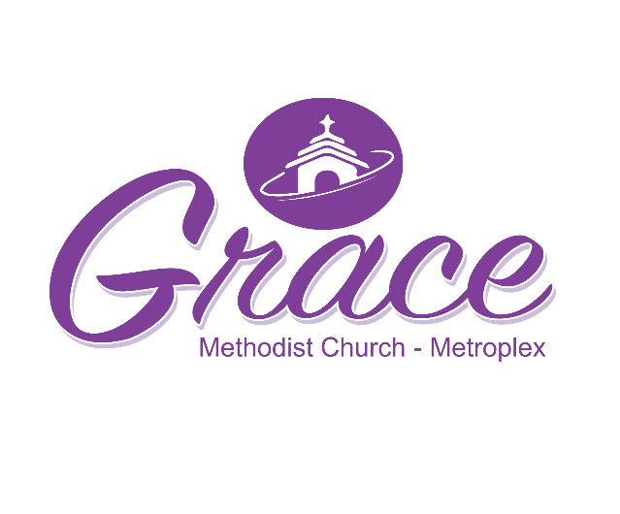
April Worship Guide
April 28, 2024

Fred Bates, Jr., Pastor
Mitchell Johnson, Associate Pastor
Dr. Alfie Wines, Pastor Emeritus
Deborah Hunte, Lay Leader

1310 S. Collard Street
Fort Worth, Texas, 76105
817-323-6276

www.gracemetroplex.org
Instagram @ Grace Methodist – Metroplex
Facebook @ Grace Methodist - Metroplex
Twitter @GraceUMC3

Grace Methodist Metroplex seeks to
bring people into a life changing relationship with Jesus Christ, by making disciples through our words and actions in cooperation with God’s grace.

EXPERIENCE GRACE!
Order of Service

Welcome / Scripture / Prayer

Praise Song

Altar Prayer – Worship

Apostle’s Creed

Welcome Guests / Announcements

Offering

Worship Song
(Release to Children’s Church)

Message from the Word
Dr. Lonzetta Allen

Invitation to Discipleship / Closing Benediction

Apostle’s Creed
I believe in God, the Father Almighty, maker of heaven and earth;
And in Jesus Christ his only Son, our Lord; who was conceived by the Holy Spirit, born of the Virgin Mary, suffered under Pontius Pilate, was crucified, dead, and buried; the third day he rose from the dead; he ascended into heaven, and sits at the right hand of God the Father Almighty; from thence he shall come to judge the quick and the dead.
I believe in the Holy Spirit, the holy catholic / universal church, the communion of saints, the forgiveness of sins, the resurrection of the body, and the life everlasting. Amen

Membership Covenant Vows of Agreement
Do you renounce the spiritual forces of wickedness, reject the evil powers of the world, and repent of sin? I do.
Do you accept the freedom and power God gives you to resist evil, injustice, and oppression? I do.
Do you confess Jesus Christ as Savior, put your whole trust in his grace, and promise to serve him as your Lord? I will.
Will you remain faithful members of Christ’s holy church and serve as Christ’s representatives in the world? I will.
Do you promise to faithfully participate in the ministries of Grace Methodist - Metroplex by your prayers, their presence, their gifts, their service, and their witness? I do.

We give thanks for all that God has already given us.
As members of the body of Christ
and in this congregation of The United Methodist Church,
we will faithfully participate in the ministries of the church
by our prayers, our presence, our gifts, our service, and our witness,
that in everything God may be glorified through Jesus Christ.

